TFS Sprint Flow
- Sprint must not be longer than 1 month. If sprint is longer than 1-month discard, that sprint and it will not be considered as sprint.
- All deployment must be done using CI\CD pipeline only. (No Manual installation\upgrade will be done)
- With Each story, we will have one code review task in which review will update their comments and if possible attach review/response email with it.
- We will have one more story in each iterations for Veracode scanning so do scanning in second last week of each sprint, resolve flaws if any comes and attach report with that story by creating one task.
- Daily Standup logs should be there in TFS for each members. (in common task)
- Daily Stand up is not optional but it is part of process.
- Communication must be done in English only so that everyone can learn required skills and they can communicate with client in future if they get any chance for it.
- During Sprint Planning, involve everyone in discussion before starting of development. Team who is going to work on same, Testing Team, Documentation Team so that all can get idea what is going to come.
- Team leader with their team, what they have done yesterday, what they are going to do tomorrow and hurdles if they are facing, will do daily Stand up.
- Sprint Review is all about product , we can discuss how all features were developed , how many changes came after our first release , how we can improve on feature development, whether we are able to meet customer expectations or not. (Development Team, Product Owner and key Stack holders will be available in this meetings), here we will also discuss about Product Backlog update.
- Sprint Retrospective is about our Team
1. What went well?
2. What did not go so well?
3. What actions need to be taken to improve?
- This should not be limited to only these questions but we need to decide action as well to answer above questions in next sprint.
- The goal of Retrospective is to receive honest feedback from every team member on every questions and then turn this feedback into an action list with steps.
- For E.g :
For example, during the retrospective you learnt that the team think they might have a problem with unexpected work: that they could not meet the sprint goal because a lot of unexpected work was coming in from outside the team.

Knowing that the team wants to get smart on this, the Scrum Master might create an action item to record details of any unexpected requests in the next sprint so that the team have the data to know where it’s coming from and what the impact is. A follow-up action might then be to come up with processes or agreements to reduce that unexpected work.
- Whenever we have new product\module at that time we will create new Agile project as below.
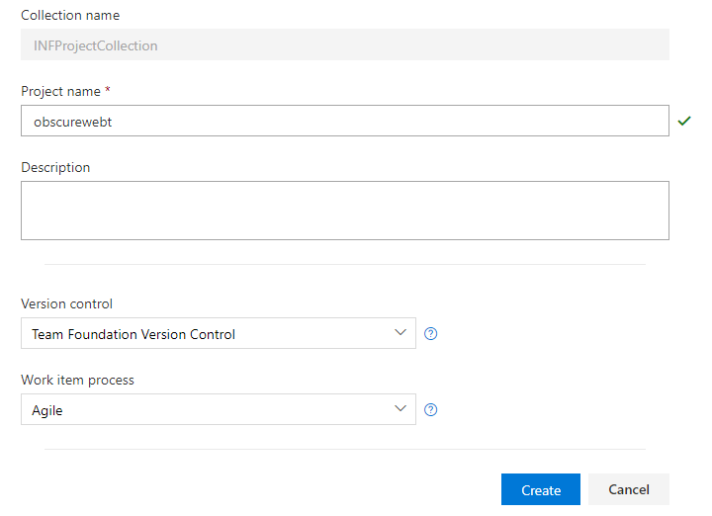
- Once project is created after that, we will bind our source code with project.
- We will start iteration wise development in project.
- Go To – Create Project – Setting Icon and Click on Work , from where we can create new iterations and manager iterations.
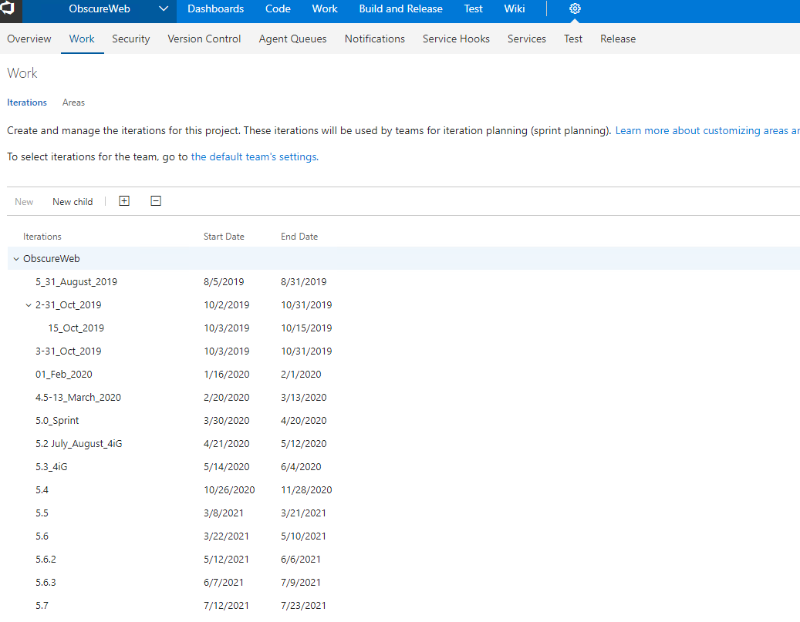
- Once we create iteration after that click on link, go to the default team’s settings link button from above window.
- From there we will click on Select Iterations button and add created iterations after that it will be visible under Work section.
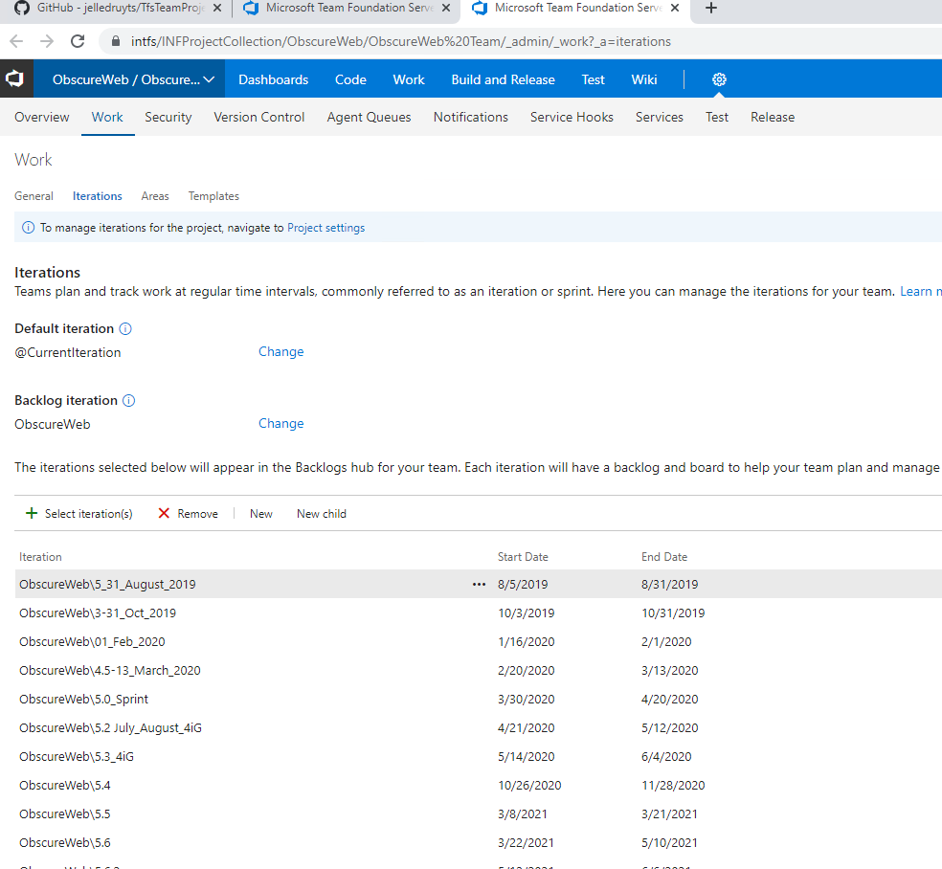
- Go to Work from Top Menu from here we will create stories; define task, report bugs and track development of team members.
Iteration

Test Cases

Test Cases

Task

Stories

- Story
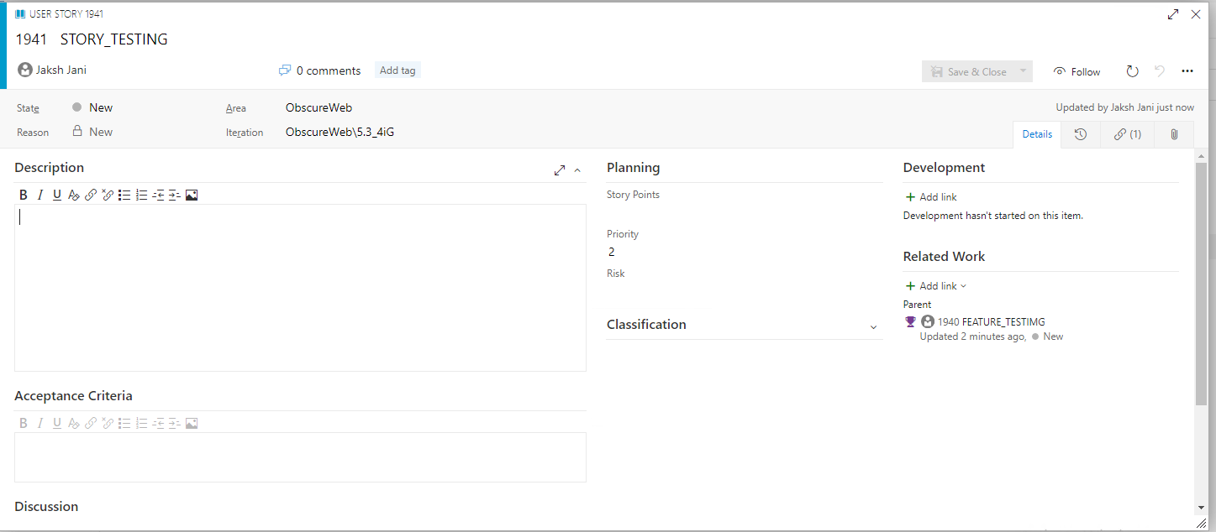

- Name of Item
- Assign To : Name of person
- State of item :Active ,resolved ,new ,removed
- IT will be always New
- Add detailed description here for team leader and technical leader.
- Planning
  - Story Points
    - It will be value like 1,3,5,8,7,15, higher the value means it will be developed first.
  - Priority :
    - 1 to 4 , 4 is Highest
  - Risk
    - High ,Low ,Medium
- Classification
  - Architectural —technical services to implement business features that deliver solution
  - Business (Default) —services that fulfill customers or stakeholder needs that directly deliver customer value to support the business
- Development
  - Reference link need to be provided
- Related Work
- Attachments
  - Attach flow if required for detail understanding of item.
- Discussions
  - In case of doubts after creating ticket, we can discuss over here so thread will be maintained it will be refer during development and testing.

- Once we create user stories after that Task will be created under that user story and developers will do estimation of Task. It will be divided into multiple tasks.
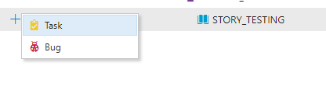
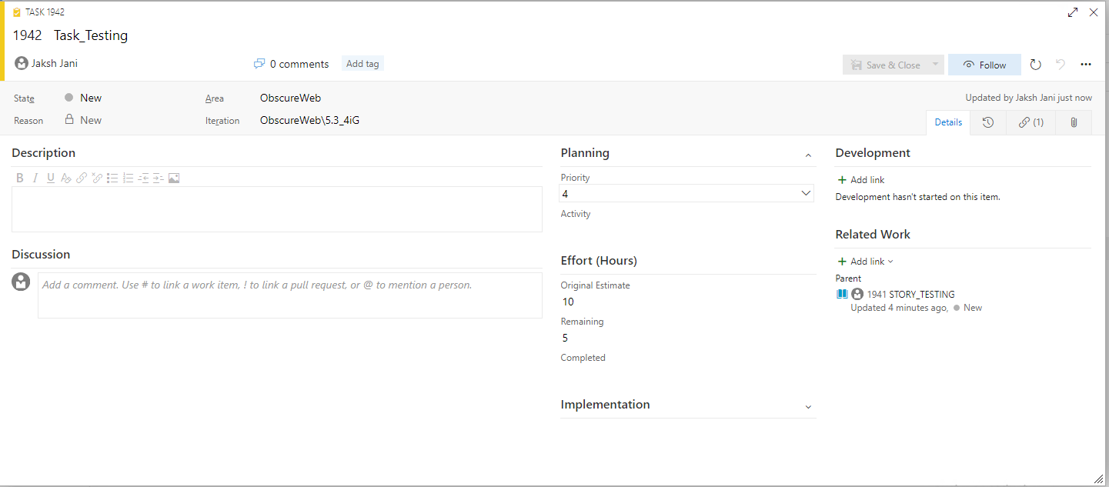
- All Developers will have Original Estimate when they create task , ideally this should be created by Team leader after discussion with them and they can daily update Remaining or completed hours so based on that we can generate reports (Resource Usage, Time Taken in Particular Item, when this will be completed and so on)
- In task two more items are there, Efforts which explained in above paragraph and Activity, task is related to what.
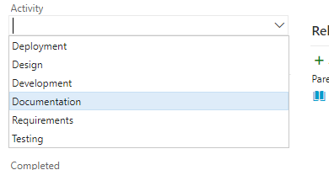
- Here we can provide proper value that this task is associated with development or proper value.

Planning Pocker
- In the Planning Poker session, the team will usually have a short discussion about requirements, in order to make sure that everyone understands them very well and, after that, each team member will estimate the effort that could be spent in delivering that work item. A crucial point here is that the team needs to understand all the work items in order to be able to estimate them. If the team does not understand the requirements well, they cannot then make a good estimation.
Test Case
- Test case will be created once developer do estimation of task and it will be linked with respective stories so that we will get link with stories and get idea about the same.

Bugs
- Once story get released after that testing will start testing on that story based on Test cases which they are designed for stories.

If created task is passed successfully without bugs then we will change status of that story to close else it will go Active/Resolved/Closed state.

